**Data collection procedures**

**Software to install:**

mmWave Studio, need to apply via TI account and request a copy.

TI mmWave SDK latest version just google

Matlab Runtime engine (make sure matlab is installed on the workstation)

XDS emulation package

**Hardware setup:**

**DCA1000(green board), IWR1443boost(Red), sample from Npark**

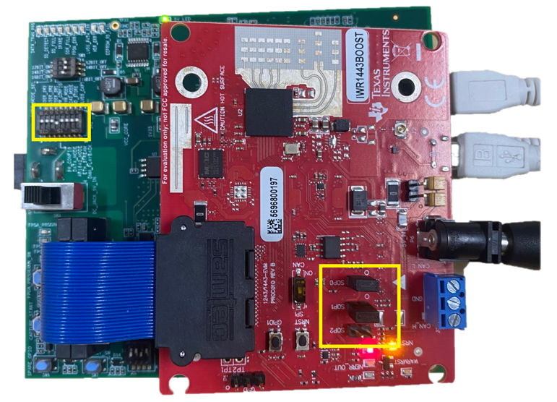

Figure 1a, 1b

Make sure the setup is as in Figure 1a and 1b. There are two USB port on DCA1000 make sure it is connect to the FTDI instead of JTAG. And power switch as in Figure 1b is to the right.

Both power supply have a on and off switch, make sure they are turned on. For more specification please see <https://dev.ti.com/tirex/explore/node?a=1AslXXD__1.20.00.11&node=A__AGTrhNYW8jE6cMxbovlfaA__radar_toolbox__1AslXXD__1.20.00.11>

Make sure the ethernet cable is connected to the workstation without adaptor, which might raise ‘Unknown FPGA version’ error. (although I used an adapter and never encountered this issue)

**Internet setup**

1. Go to network setting and change adaptor options

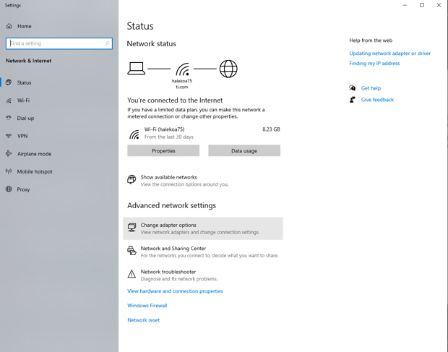

1. Click on the Ethernet unidentified network and go to property. Go to IPv4 and click on property, and change the ip address as following.

Go to Device manager, click on ports, make sure it is like as below, and take note on the boxed COM number.

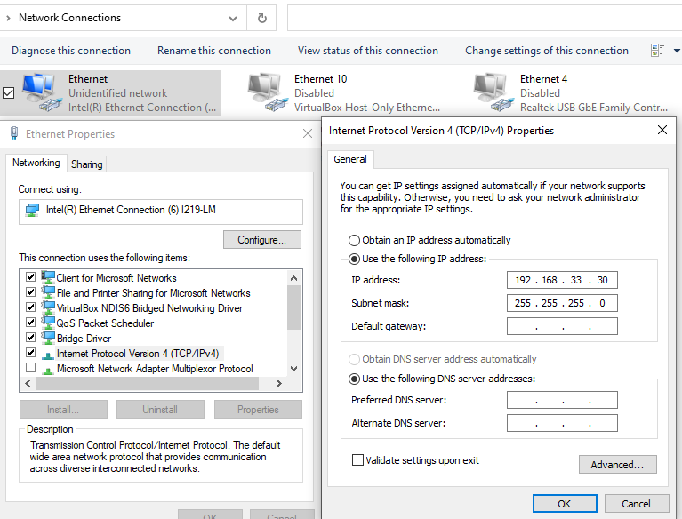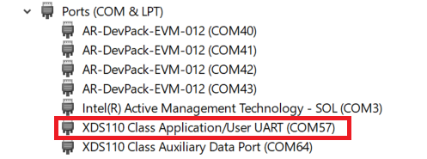

com 6 3 for pc

com 5

**Software Instruction**

First you go to Connection

Follow the index as order to click on these to connect with the DCA1000 + xwr14xx

On files section, BSS you go to mmWave_studio\rf_eval_firmware\radarss\xwr12xx_xwr14xx…

MSS you go to mmWave_studio\rf_eval_firmware\masterss\xwr12xx_xwr14xx…

Then you go to staticConfig

Follow the box order and set the parameter.

Then you go to DataConfig

Make sure all the parameter are as follow and click on the set

Then go to SensorConfig

Click on the Setup DCA1000, and click connect.

Then go back and set the parameter like these and click on set.

Note: on section Frame the No of Frames allow you to determine how much data you want to collect. Default is 8 which gives aroung 4 kb output, we want about 4 mb output so adjust to it.

On the Capture and post processing part the path below is how you want to save the adc_data.bin, make sure you name it properly, with index or label.

Then click on the DCA1000 Arm and Trigger Frames, and wait for the result.